**50 Scale ED Mapping Upgrade v1.2**

1. 20056: Update the Device Group Subsurface Interrupter Size

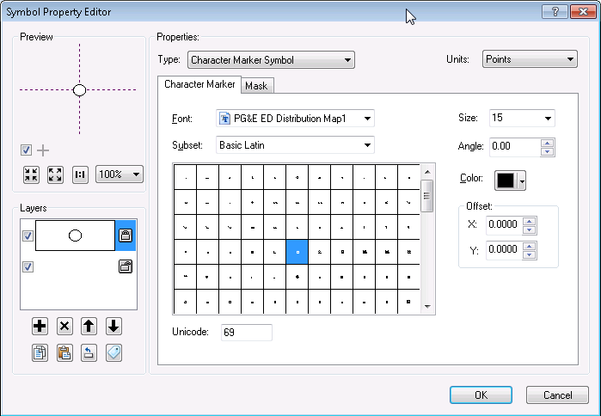 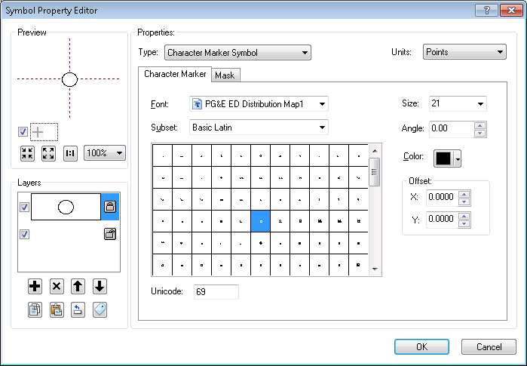

1. 20056: Reduce the masking of the Interrupter symbol

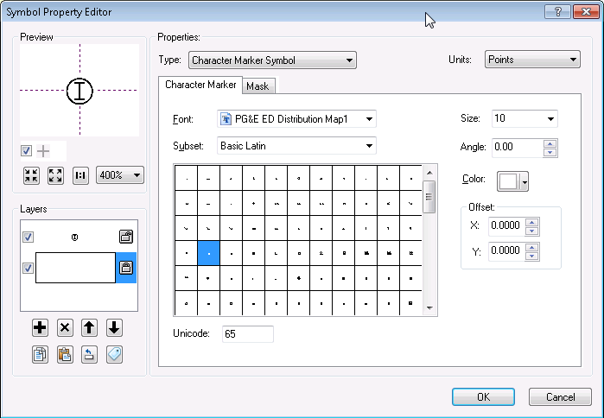 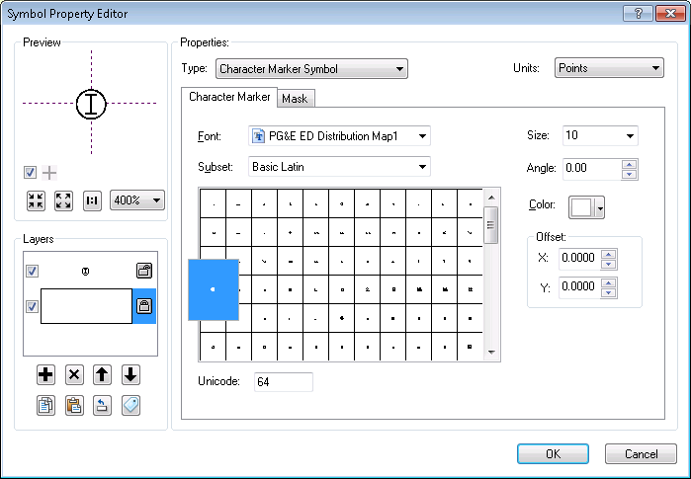

Once 1 and 2 are completed, the change should be as follows:

 

1. 20059: Add the DC Conductor and DC Device annotation layers

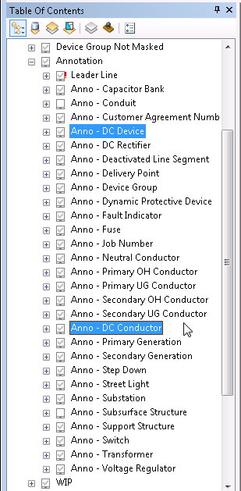

1. 20066: Remove the ULS Primary Conductor layer

